<http://www.sportsscience.co/flexibility/whole-body-stretching-routine/>

30 seconds per muscle is optimal and frequency of 3-7 times per week is recommended.

Neck Flexion/Extension Stretch

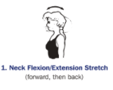

Neck Lateral Flexion Stretch

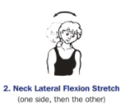

Latissimus Dorsi and Posterior Deltoid Stretch

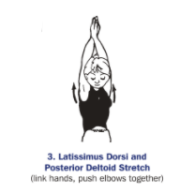

Triceps Stretch

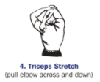

Shoulder Rotator Stretch

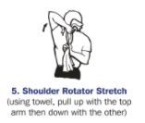

Bicep Stretch

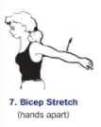

Supraspinatus Stretch

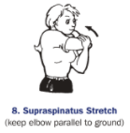

Wrist Extensor Stretch

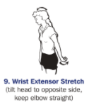

Thoracic Extension Stretch

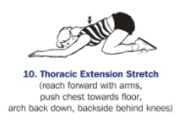

Lying Hamstring Stretch

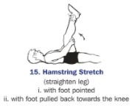

Seated Hamstring Stretch

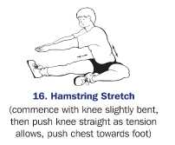

Seated Adductor Stretch

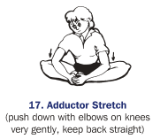

Gluteal Stretch

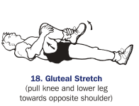

Lying Quadriceps Stretch

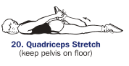

Standing Quadriceps Stretch

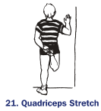

Standing Adductor Stretch

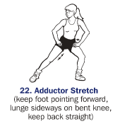

Hip Flexor Stretch

